**Project Design Phase-II**

TEAM ID: PNT2022TMID12095

PROJECT NAME: PREDICTING THE ENERGY OUTPUT OF WIND TURBINE BASED ON WEATHER CONDITION

**Data Flow Diagrams:**

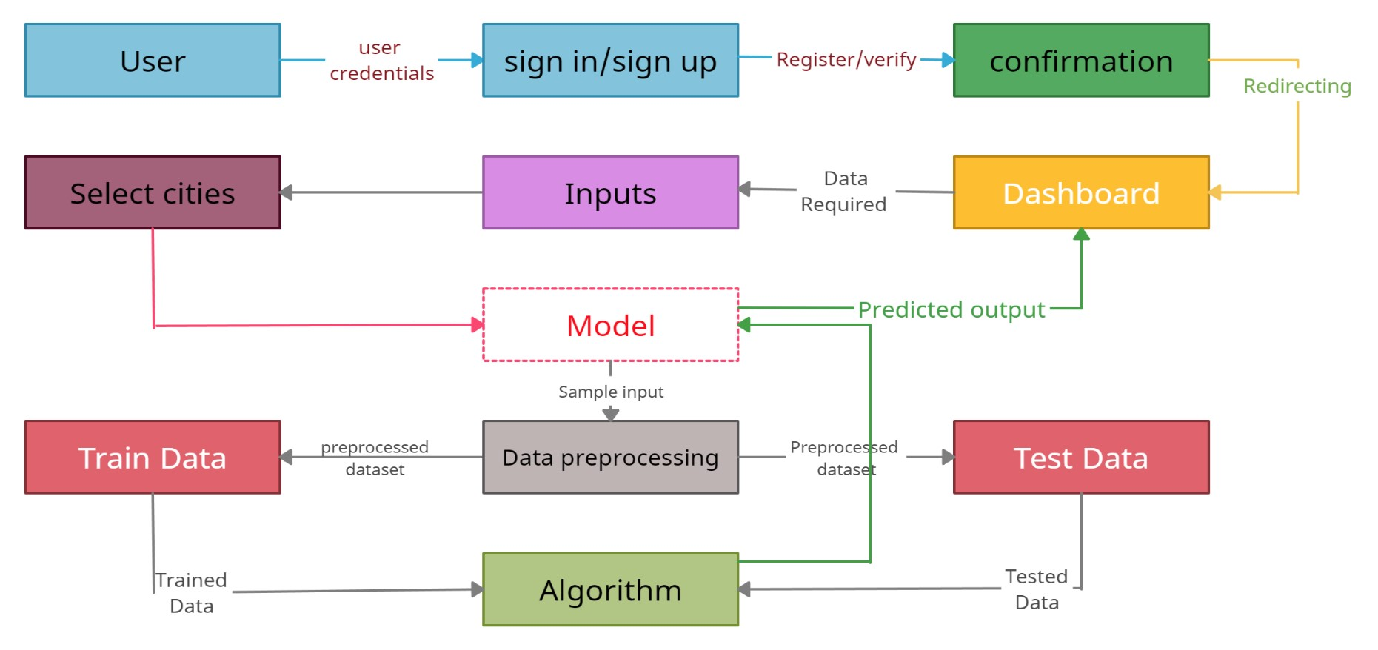

**User Stories**

Use the below template to list all the user stories for the product.

|  |  |  |  |  |  |  |
| --- | --- | --- | --- | --- | --- | --- |
| **User Type** | **Functional**  **Requirement (Epic)** | **User Story**  **Number** | **User Story / Task** | **Acceptance criteria** | **Priority** | **Release** |
| Customer  (Mobile user) | Registration | USN-1 | As a user, I can register for the application by entering my email, password, and confirming my password. | I can access my account / dashboard | High | Sprint-1 |
|  |  | USN-2 | As a user, I will receive confirmation email once I have registered for the application | I can receive confirmation email & click confirm | High | Sprint-1 |
|  | Login | USN-3 | As a user, I can log into the application by entering email & password | I can access the dashboard | High | Sprint-1 |
|  | Dashboard | USN-4 | User can get information about wind energy. He can able to see a button called predict energy by clicking the button he can give input. | I can predict for single sample | High | Sprint-1 |
| Customer (Web user) |  | USN-5 | Once I enter the Dashboard I can give input values by choosing a city | I can predict the energy production of selected city | High | Sprint-1 |
|  |  | USN-6 | As a user I can get visual representation of the prediction | I can have single output | High | Sprint-1 |
|  |  | USN-7 | As a user I can view the detailed report of my prediction | I can access details of my process and prediction | Medium | Sprint-1 |
| Customer Care Executive | Documentation | USN-8 | As a helper I can refer the documentation for support and guidance | I can use user manual for guidance | Medium | Sprint-1,2, 3,4 |
| Administrator | Settings | USN-9 | As a developer I can access dashboard’s settings and view the API token | I can view the API token for creating request | Low | Sprint-4 |
|  | Feedback | USN-10 | As a developer I can able to view user feedbacks | I can customize these web page based on feedback | Medium | Sprint-4 |